Low-Dimensional Organic Conductors for Thermoelectric Applications

Jens Pflaum
Institute of Experimental Physics VI, Julius Maximilian University, Würzburg, Germany
Bavarian Center for Applied Energy Research (ZAE Bayern e.V.), Würzburg, Germany
e-mail: jpflaum@physik.uni-wuerzburg.de

The intriguing properties of low-dimensional organic conductors distinguish them as interesting candidates for thermoelectric applications. In particular, their anisotropic metallic-like electrical conductivity reaching values of up to 10⁵ S/m at room temperature in combination with a poor thermal transport characteristic for weak van-der-Waals bound crystals favor figures of merit, zT = (σ S²/κ)T, that are of technological relevance. By the correlated electron system and its strong coupling to the surrounding lattice remarkable phenomena emerge, like phonon drag effects or the violation of the Wiedemann-Franz law, which support the implementation of organic conductors in future thermoelectrics even further [1].
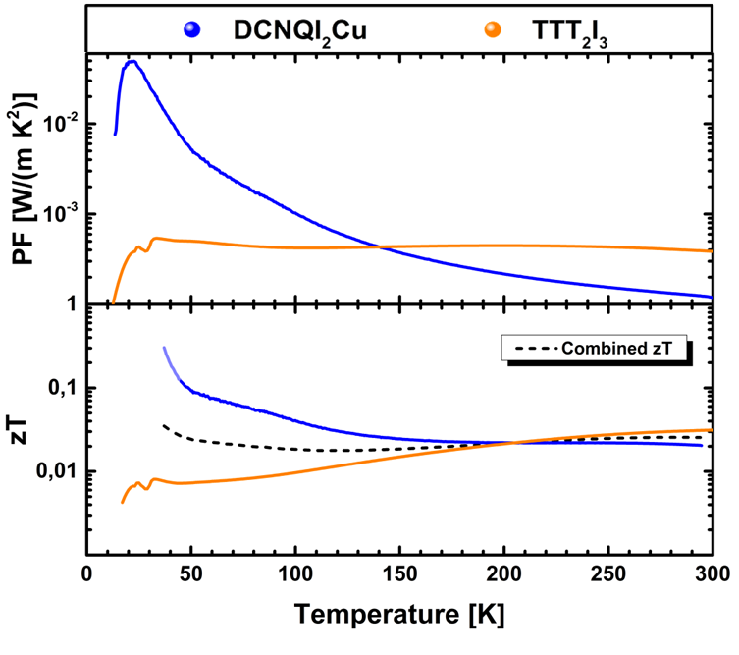
Fig.1 Temperature dependent power factor of n- and p-type conducting DCNQI₂Cu and TTT₂I₃ radical ion salt crystals, respectively, (upper graph) and the related figures of merit (lower graph). From [2].
After introductory remarks on low-dimensional organic conductors and their correlated structural and electronic properties, we will demonstrate by means of two representatives of this class, the n-conducting DCNQI₂Cu radical ion salt and the one-dimensional p-conductor TTT₂I₃, the complex thermoelectric behavior as function of temperature (see Fig. 1) [2]. Based on this information and the interdependence of the relevant quantities an all-organic thermoelectric generator comprised of the two organic conductors will be presented as a proof-of-concept and compared in its performance with alternative approaches. Strategies to further improve the thermoelectric performance of these low-dimensional organic conductors and their technological potential will be highlighted.

References
1. F. Huewe et al., Phys. Rev. B 92, 155107 (2015)
2. F. Huewe, et al., Adv. Mater. 29, 1605682 (2017)

