A Neural Network Approach for Structural Characterization of Metal Nanoparticles and Clusters
Janis Timoshenko,¹ Nicholas Marcella,¹ Yang Liu¹, Anatoly I. Frenkel^{1,2}
¹ Department of Materials Science and Chemical Engineering, Stony Brook University, USA
² Division of Chemistry, Brookhaven National Laboratory, USA

Tracking the structure of heterogeneous catalysts under operando conditions remains a challenge due to the paucity of experimental techniques that can provide atomic-level information for catalytic metal species. Here we report on the use of X-ray absorption near edge structure (XANES) spectroscopy and artificial neural network for refining the three-dimensional geometry of metal catalysts. Neural network is used to unravel the hidden relationship between the XANES features and catalyst geometry. To train the neural network, we rely on the ab-initio XANES simulations by theoretical spectroscopy codes. Our approach allows one to solve the structure of a metal catalyst from its experimental XANES, as demonstrated here by reconstructing the average size, shape and morphology of well-defined mono- and bimetallic nanoparticles.¹ In the case of ultra-small clusters their average size can be estimated. This method is applicable to the determination of the structure of metal catalysts in operando studies and can be generalized to other nanoscale systems. It also allows “on-the-fly” XANES analysis, which is a required step for high-throughput and time-dependent studies, including the “reaction on demand” capabilities.

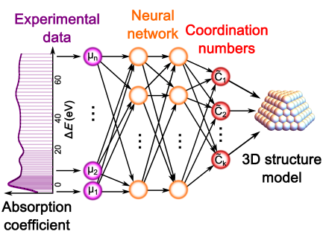
Figure 1. Illustration of the Machine Learning approach: feature space (absorption coefficient values) is mapped by neural network to nanoparticle-averaged coordination numbers that for well-defined particles can be interpreted in terms of specific sizes, shapes and structures.

A.I.F. acknowledges support of this work by the Division of Chemical Sciences, Geosciences, and Biosciences, Office of Basic Energy Sciences of the U.S. Department of Energy through Grant DE-FG02- 03ER15476.
References
¹ J. Timoshenko, D. Lu, Y. Lin, A. I. Frenkel, J. Phys. Chem. Lett. 8, 5091-5098 (2017).

