ESS and its contributions to future functional materials and nano technology

Andreas Schreyer¹
¹European Spallation Source, P.O Box 176, SE-221 00 Lund, Sweden
e-mail: andreas.schreyer@esss.se

The European Spallation Source (ESS), which is currently under construction in Lund, Sweden, is designed to push the limits of research with neutrons to new horizons. ESS will open up new scientific opportunities which are complementary to those at X-ray sources. These will include unprecedented in-situ and in-operando experiments which are only possible with neutrons due to their special properties.
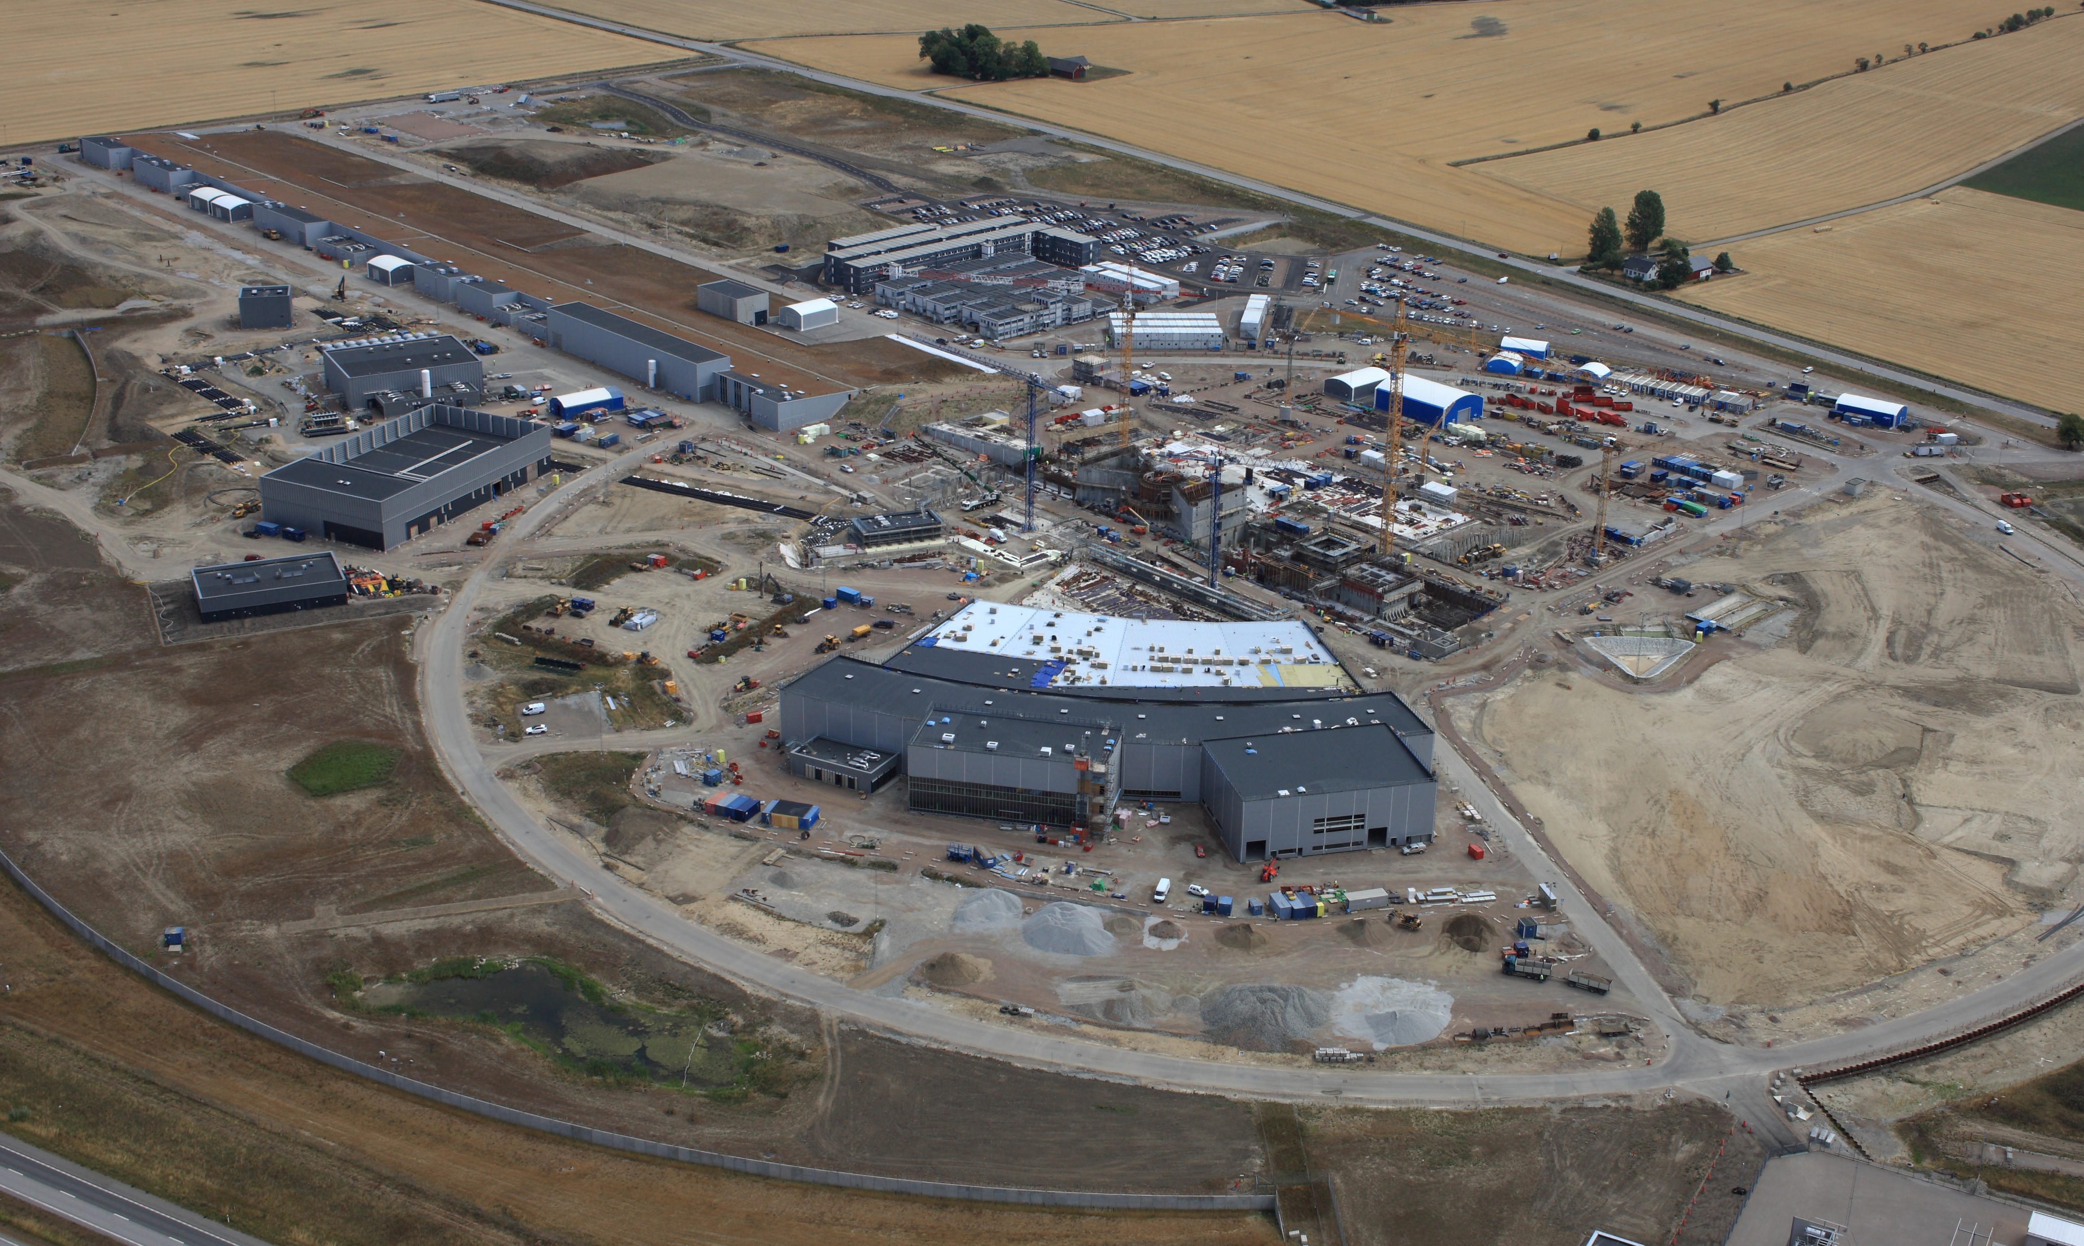

Fig.1 The Photo shows a recent view of the ESS construction site.
After a short summary of the design and the specifications of the European Spallation Source an overview of the current status and schedule of the ESS construction project will be given with a strong focus on the instruments and the surrounding scientific infrastructure. The overall goal of ESS is to begin user operation in 2023 and ramp up to 15 instruments by the end of 2026. Selected examples of new scientific opportunities in the field of functional materials and nano technology will be discussed.

