Tony Donné 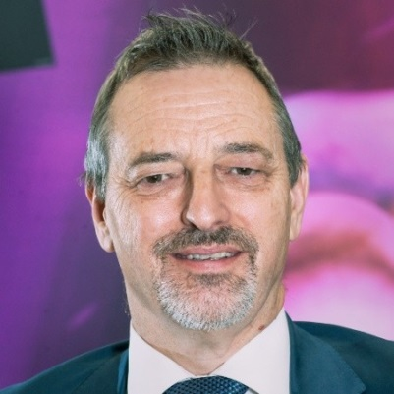

Programme Manager (CEO) of EUROfusion European consortium

Munich Area, Germany
Tony Donné (1956) is since June 2014 Programme Manager (CEO) of EUROfusion, a European consortium of 30 national fusion research institutes in 26 EU countries plus Switzerland and Ukraine. Before that he was head of the Fusion Physics Division at the Dutch Institute for Fundamental Energy Research (DIFFER) and responsible for the coordination of the nuclear fusion research in the Netherlands. In 2010 he was interim director of the institute. From January 2010 - January 2018 he was professor in Diagnostics and Heating of Fusion Plasmas at Eindhoven University of Technology. From 2008 - 2014 he was director of the Dutch-Russian Centre of Excellence on Fusion Physics and Technology, as well as programme director of the ITER-NL consortium.
Almost his entire career he worked in plasma diagnostics at a large range of tokamaks. As chair of the ITPA and EFDA Topical Group on Diagnostics, he was closely involved in the development of diagnostics for the international ITER project. He was member of the Governing Board of Fusion for Energy (F4E), the European Domestic Agency for ITER as well as member of the EURATOM Scientific and Technical Committee (STC). He is presently member of the ITER Scientific and Technology Advisory Committee, the Coordinating Committee of the International Tokamak Physics Activity, the Supervisory Board of the Max-Planck Institute for Plasma Physics and the International Advisory Committee of the EAST tokamak. He is chair of the IEA Cooperation of Tokamak Programmes and from July 2018 until July 2019 he will chair EIROforum.
Until 2017 he chaired the physics advisory board of the Lorentz Centre in Leiden and he acted in organizing committees (in different functions: chair, secretary, treasurer, member) of many conferences and symposia. He is member of the Board of Editors of the peer-reviewed journal Nuclear Fusion.
He published about 185 papers in peer-reviewed journals and more than 350 conference proceedings.

