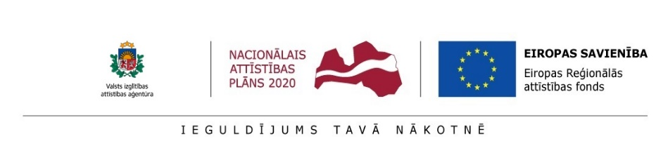

Date: June 6, 2018 at 10:00 – 16:00

Venue: Institute of Solid State Physics, University of Latvia (ISSP UL), conference room on 2nd floor, 8 Kengaraga Street, riga

WHY: in the framework of Programme Horizon 2020 Project CAMART²

WHAT: Brokerage event: h2020, fp9 and nordic-baltic network

ORGANIZERS: issp UL & State education development agency`s (SEDA) HORIZON 2020 NATIONAL CONTACT POINT (Horizon 2020 NCP)

Programme:
9:30 – 10:00 Registration, Coffee
10:00 - 10:20 Opening, by ISSP UL& SEDA Horizon 2020 NCP representatives
10:20 – 10:50 Project CAMART² - Perspectives and progress, by Project Leader Martins Rutkis
10:50 – 11:10 Proposal for a new framework programme for research and innovation - FP9, by invited speaker from EC (tbc)
11:10 – 11:30 Spreading of Excellence – ideas for the next Research Programme, by invited speaker from EC (tbc)
11:30 – 12:50 UK Science and Innovation Nordic-Baltic Network: Development of new bilateral R&D relationships between UK and Latvian institutions, by the UK Science and Innovation Attaché to Baltic States Migle Masaityte

12:50 – 13:10 Panel discussion – New features in FP9 – mission oriented research and innovation and improving cooperation
13:10 –14:10 Lunch break
14:10– 15:30 HORIZON 2020 OPPORTUNITIES FOR REASEARCH, INNOVATION, COOPERATION AND BUSSINESS
- Horizon 2020 opportunities for public and private sectors, by NCP Coordinator Janis Ancans
- ICT in Horizon 2020, by NCP Senior Expert Julija Asmuss

BUSSINESS CASE – SME AND APPLIED RESEARCH PERSPECTIVES
- Five steps towards start for entrepreneurs, by NCP Senior Expert Iveta Cirule
- Opportunities to recruit qualified personnel, by SEDA PostDoc Project coordinator Ineta Kurzemniece

15:30- 16:30 Coffee and snacks
Networking & informal Horizon 2020 NCP expert consultations
REGISTRATION: please register online by June 1, 2018
Working languages: English and Latvian

