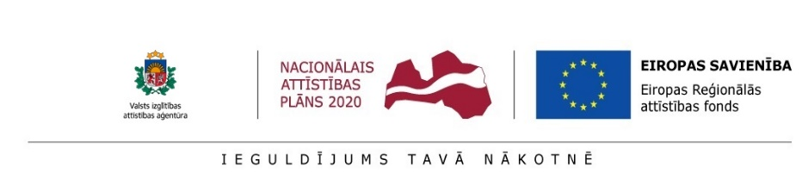

Date: June 6, 2018 at 11:30 – 16:00

Venue: Institute of Solid State Physics, University of Latvia (ISSP UL), conference room on 2nd floor, 8 Kengaraga Street, riga

WHY: in the framework of Programme Horizon 2020 Project CAMART²

WHAT: Brokerage event: h2020, Horizon Europe and nordic-baltic network

ORGANIZERS: issp UL & State education development agency`s (SEDA) HORIZON 2020 NATIONAL CONTACT POINT (Horizon 2020 NCP)

Programme:
11:30 – 11:45 Registration
11:45 - 12:00 Opening, by ISSP UL& SEDA Horizon 2020 NCP representatives
12:00 – 12:20 Project CAMART² - Perspectives and progress, by Project Leader (Director of ISSP UL) Martins Rutkis
12:20 – 12:40 Proposal for a new framework programme for research and innovation - Horizon Europe, by Deputy Director of Research of ISSP UL Andris Sternbergs
12:40 – 13:00 UK Science and Innovation Nordic-Baltic Network: Development of new bilateral R&D relationships between UK and Latvian institutions, by the UK Science and Innovation Attaché to Baltic States Migle Masaityte
13:00 –13:30 Snacks& networking
13:30– 15:00 HORIZON 2020 OPPORTUNITIES FOR REASEARCH, INNOVATION, COOPERATION AND BUSSINESS
- Horizon 2020 opportunities for public and private sectors, by NCP Coordinator Janis Ancans
- ICT in Horizon 2020, by NCP Senior Expert Julija Asmuss

BUSSINESS CASE – SME AND APPLIED RESEARCH PERSPECTIVES
- Five steps towards start for entrepreneurs, by NCP Senior Expert Iveta Cirule
- Opportunities to recruit qualified personnel, by SEDA PostDoc Project coordinator Ineta Kurzemniece

15:00- 16:00 Coffee and snacks
Networking & informal Horizon 2020 NCP expert consultations
REGISTRATION: please register online by June 1, 2018
Working languages: English and Latvian

