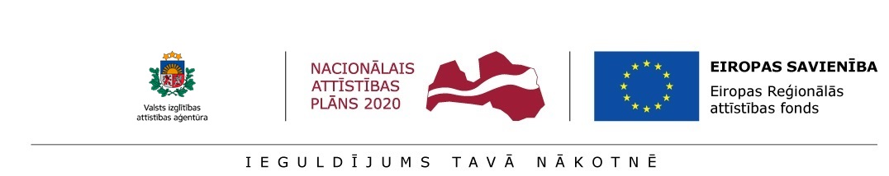
Annex 1.6
INFORMATION on the consultant from the sector of science/national economy
for preliminary selection of postdoctoral applications at the
Institute of Solid State Physics, University of Latvia
for submission to the State Education Development Agency (SEDA) for the research application selection round for Activity 1.1.1.2 “Post-doctoral Research Aid” of the Specific Aid Objective 1.1.1 “To increase the research and innovative capacity of scientific institutions of Latvia and the ability to attract external financing, investing in human resources and infrastructure” of the Operational Programme “Growth and Employment”

Consultant from the sector of science/national economy:
Name, family name
Institution, sector, position
Qualifications of the consultant from the sector of science/national economy and experience in the field of research related to the research application:
International cooperation

Participation in projects

publications
patents
Other achievements related to the research application over the preceding 5 years

Postdoctoral researcher _______________ /__________________/ ____._____. 20____.
signature name

