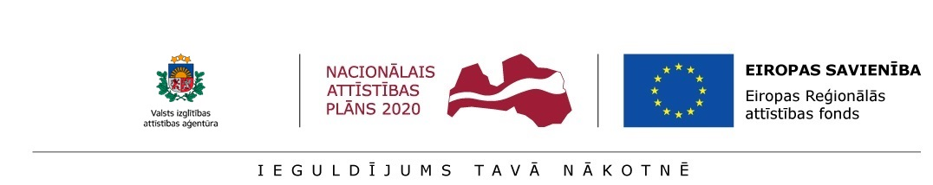
Annex 1.5
INFORMATION ON COLLABORATION PARTNER
for preliminary selection of postdoctoral applications at the
Institute of Solid State Physics, University of Latvia
for submission to the State Education Development Agency (SEDA) for the research application selection round for Activity 1.1.1.2 “Post-doctoral Research Aid” of the Specific Aid Objective 1.1.1 “To increase the research and innovative capacity of scientific institutions of Latvia and the ability to attract external financing, investing in human resources and infrastructure” of the Operational Programme “Growth and Employment”

COOPERATION PARTNER :

Prior experience and participation in research and mobility programmes (during the preceding 5 years)
Current participation in research and mobility programmes
Most relevant publications and/or developed research/innovation projects during the preceding 5 years
Doctoral Theses prepared and defended

Postdoctoral researcher _______________ /__________________/ ____._____. 20____.
signature name

