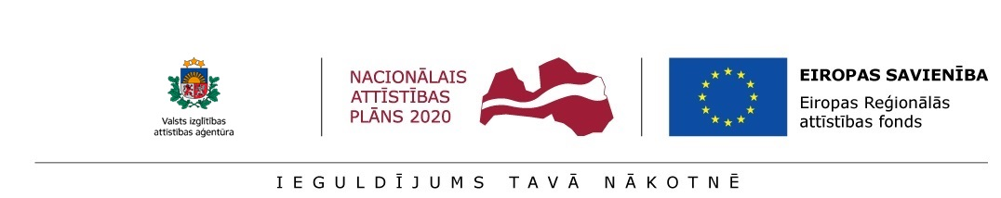
Annex 1.4
STATEMENT OF THE POSTDOCTORAL RESEARCHER
__. __. _________.
By my signature below, I,____________, id. No. ____________ , hereby certify and confirm that I apply for aid within the frame of Activity 1.1.1.2 “Post-doctoral Research Aid” of the Specific Aid Objective 1.1.1 “To increase the research and innovative capacity of scientific institutions of Latvia and the ability to attract external financing, investing in human resources and infrastructure” of the Operational Programme “Growth and Employment” and:
- I have never before received aid within the frame of Activity 1.1.1.2 “Post-doctoral Research Aid” of the Specific Aid Objective 1.1.1 “To increase the research and innovative capacity of scientific institutions of Latvia and the ability to attract external financing, investing in human resources and infrastructure” of the Operational Programme “Growth and Employment”;
- in the event of being awarded aid for the research application I will not receive remuneration within the frame of this Activity and within the scope of Activity 1.1.1.1 “Practical Research Aid” and Activity 1.1.1.3 “Innovation Grants to Students” of the Specific Aid Objective 1.1.1 “To increase the research and innovative capacity of scientific institutions of Latvia and the ability to attract external financing, investing in human resources and infrastructure” of the Priority Action “Research, Technology Development and Innovations” of the Operational Programme “Growth and Employment”;
- I will not receive remuneration in another project or place of work except the case when the postdoctoral researcher’s employment – outside the research application implementation – in academic work (except the leading researcher, researcher, research assistant) or in conducting contractual research commissioned by an enterprise does not exceed 0.2 FTE (full time equivalent)
____________________________(signature)

