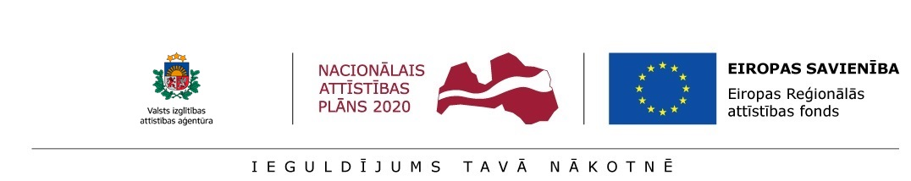

Annex 1.1

APPLICATION

for preliminary selection of postdoctoral applications at the
Institute of Solid State Physics, University of Latvia
for submission to the State Education Development Agency (SEDA) for the research application selection round for Activity 1.1.1.2 “Post-doctoral Research Aid” of the Specific Aid Objective 1.1.1 “To increase the research and innovative capacity of scientific institutions of Latvia and the ability to attract external financing, investing in human resources and infrastructure” of the Operational Programme “Growth and Employment”

Name | First name
email address/ telephone No.
Citizenship / country of residence

Name, surname of the applicant
Title of the application
Person responsible for the research of the research application (consultant from the sector of science or national economy)
Sector/ subsector of science of the research theme
Sector/ subsector of science of the research theme
Type of the research application: (related to economic activity or not related to economic activity)

Documents appended: | Research project proposal – Annex 1.2
 | Curriculum vitae (CV) – Annex 1.3
 | Statement by the postdoctoral researcher - Annex 1.4
 | Information about the readiness of the cooperation partner to participate in research application implementation (if the project envisages a cooperation partner) – Annex 1.5
 | Information about the potential consultant from the sector of science or national economy – Annex 1.6
 | A copy of the diploma of the doctoral degree or a formal acknowledgement from the Academic Information Centre (AIC) about the recognition of the doctoral degree if it has been awarded abroad
 | Other documents:
Documents to be submitted if the postdoctoral researcher submits a project for attraction of a foreign postdoctoral researcher, which was submitted in the Marie Skłodowska-Curie action “Individual Fellowships” of the EU Framework Programme for Research and Innovation “Horizon 2020” and was evaluated above the quality threshold in the abovementioned evaluation of project applications, however, did not receive funding for project implementation | Assessment of the research quality of the project by experts included in the European Commission database of experts
 | Decision of the European Commission on the approval of the project
 | A copy of the Project application submitted within the frame of the Marie Skłodowska-Curie action “Individual Fellowships” of the EU Framework Programme for Research and Innovation “Horizon 2020”

Postdoctoral researcher ____________________ /__________________/ ____._____. 20____
signature name
Documents received at the Institute of Solid State Physics, University of Latvia.

_____.______ . 20___ _____________________ /__________________/
signature name

Notes:
1. Sections marked with * are filled in by the project administration.
2. The Institute of Solid State Physics, University of Latvia will use data indicated in the application only for the purpose of research application administration.

