Pielikums Nr. 1

Smart buoy for the monitoring of aquatic organisms and assessment of water quality (Spectromarine)

Riga, September 4th, 2023

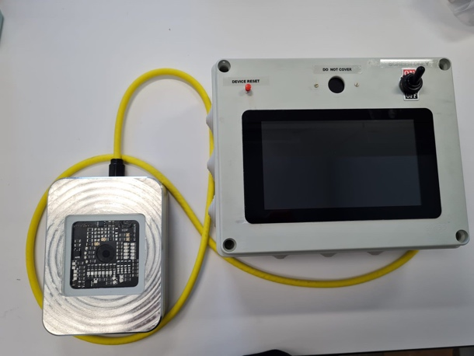
“Spectromarine” is a portable and fully automated optical device for monitoring of water quality and aquatic microorganisms (see Figure 1). The device can be mounted on any platform – buoy, boat, fish farm or in pools of water. Main focus is automated data acquisition, analysis and low maintenance operation for truly “Industry 3.0” integration.

Sea pollution in the world and Baltic Sea region creates hazards to human health and marine organisms. Besides pollution, anthropogenic activity can lead to a massive surge in phytoplankton abundance, causing algae bloom. Harmful algal blooms (HAB) can have serious human health complications, as algal toxins are associated with various diseases as well devastating economic losses due to contamination and losses of coastal fish farm stock for the aquaculture industry.
Figure 1: Spectromarine prototype v3

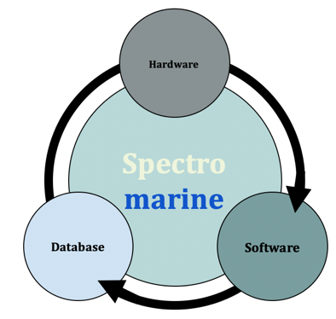
A novel spectrometer-based approach for pollutant and microorganism detection opens up new ways of penetrating the market by being significantly cheaper than current equivalent solutions. A device like this would benefit the rapidly growing industry of aqua-farms, increasing yields, avoiding loss, avoiding pollution and for choosing the optimal location for farming.

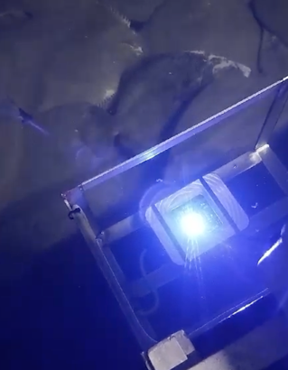
The Spectromarine technology consists of three main parts: hardware, software, and database (see Figure 2). While hardware and software are developed simultaneously, the database will be acquired at the later stages of the development and constantly expanded from already implemented and operating devices.
Figure 2 Core elements of technology
Figure 3 Spectromarine prototipe in field tests
The key innovation of the hardware is in the implementation of mini spectrometers with a carefully chosen filter and LED set. The hardware is coupled with a well tested software for data acquisition and analysis.

Technology is currently being developed in an EU funded R&D project. Current TRL is 6 (see Figure 3). Technology demonstrated in relevant environment.
More information on the project can be accessed here: www.spectromarine.com

IP STATUS

Intellectual Property consists of:
- registered European patent application Nr.EP23162941.1 "An automated optical spectroscopy device for water analysis"
- know-how in Technology elements

Contacts
Technical matters:  Aleksejs Zolotarjovs  Project leader  SPECTROMARINE project  Institute of Solid State Physics  University of Latvia  aleksejs.zolotarjovs@cfi.lu.lv  Mob. +371 28389973 | Administrative matters:  Girts Ozolins  Senior expert innovations  Development department  Institute of Solid State Physics  University of Latvia  girts.ozolins@cfi.lu.lv  Mob. +371 26522982

