Appendix No. 1

Mass-manufacturable gut-on-chip technology
The Institute of Solid State Physics, University of Latvia (ISSP UL) is developing miniature human organ replicas, known as organs on a chip (OOC), to help pharmaceutical companies, contract research organisations, nutrition & supplement manufacturers as well as academic institutions to perform pre-clinical tests in human-relevant tissue models. Since around 60% of commercially available drug products are administered via the oral route, current work is focused on a patent- pending gut on chip model with a particular interest in microbiota applications.
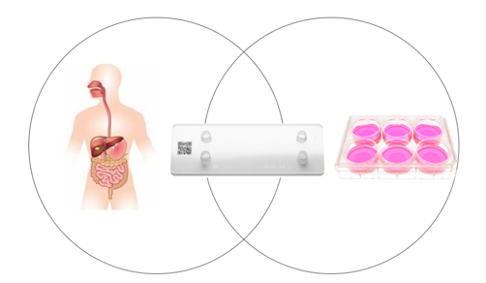
The core principle was to take a holistic approach in development of the chip, therefore putting the engineering and design work in the foreground. The resulting solution is based around chip design and material combination that is suitable for mass manufacturing and precise cell-level organ function recapitulation. For development of an easy to use, plug-and play system suitable for higher throughputs a chip-compatible instrument should be used to run the biological experiments.
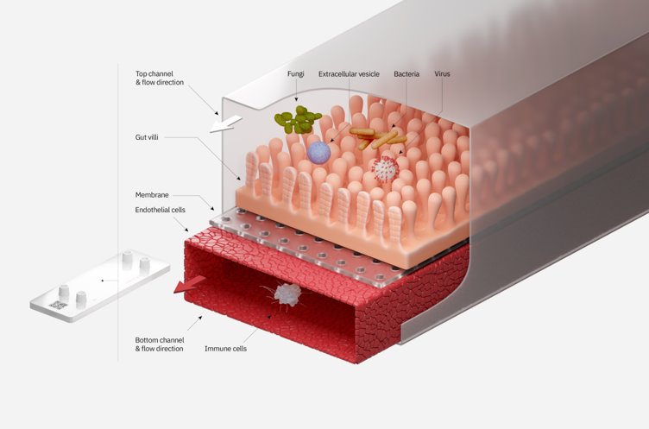
Gut-on-chip technology features:
• Use of small hydrophobic molecule non-absorbing materials
• Materials suitable for volume manufacturing
• Less gas-permeable materials
• Integrated oxygen and TEER sensors in the chip
• High transparency across 300-800 nm wavelengths and thin bottom lid

Resulting in the following customer benefits:
• More repeatable and accurate biological in vitro model for precise decision making
Potential applications:
• Drug candidate discovery
• Drug and treatment testing
• Early-stage pharmacology studies
• Disease modelling
• PK/PD studies
• Preclinical toxicology testing
• Personalised patient model system development
• Easy to integrate, use and operate for scientists & researchers
• Truly anaerobic conditions in channels with highly controllable gas conditions
• Devices suitable for high resolution microscopy
• Significantly reduced biological variation
• Increased experimental throughput
Biological testing status:
• Initial model demonstrated with stable cell lines of CaCo2 and HUVEC, iPSC model in development
• The model performs from 20 – 30% better than current state of the art OOC in terms of saving time and barrier replication accuracy
• It has been demonstrated for the first time that a patient-derived diverse anaerobic microbiota can be cultured in a gut on chip

Project No. KC-PI-2020/24 https://www.cfi.lu.lv/en/research/projects/european-regional-development-fund/mass-manufacturable-gut-on-a-chip-device/
Front. Pharmacol., 19 February 2021 | https://doi.org/10.3389/fphar.2021.618411
EP application No.: 21215336.5. “A MICROFLUIDIC DEVICE FOR SIMULATING ORGAN FUNCTIONS”

