Pielikums Nr. 1

Mass-manufacturable gut-on-chip
The Institute of Solid State Physics, University of Latvia (ISSP UL) is developing miniature human organ replicas, known as organs on a chip (OOC), to help pharmaceutical companies, contract research organisations, nutrition & supplement manufacturers as well as academic institutions perform pre-clinical tests in human-relevant tissue models. Since around 60% of commercially available drug products are administered via the oral route, our current work is focused on a patent pending gut on chip model with a particular interest in microbiota applications.
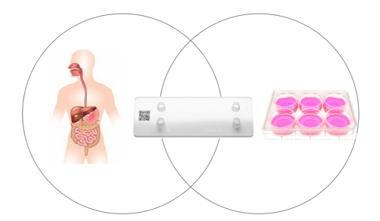
Our core principle was to take a holistic approach in development of the chip, therefore putting the engineering and design work in the foreground. Our resulting solution is based around chip design perfection and material combination that is suitable for mass manufacturing and precise organ function recapitulation. For development of an easy to use, plug-and play system suitable for higher throughputs, we are partnering with Cellbox Labs LLC that is developing a chip-compatible instrument.
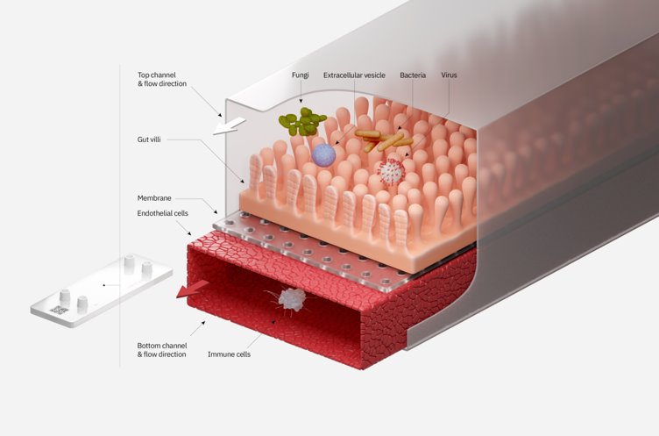
Our technology features:
• Use of small molecule non-absorbing materials
• Materials suitable for volume manufacturing
• Less gas-permeable materials
• Integrated oxygen and TEER sensors in the chip
• High transparency across 300-800 nm wavelengths and thin bottom lid

Resulting in the following customer benefits:
• More repeatable and accurate biological in vitro model for precise decision making
Potential applications:
• Drug candidate discovery
• Drug and treatment testing
• Early-stage pharmacology studies
• Disease modelling
• PK/PD studies
• Preclinical toxicology testing
• Personalised patient model system development and storage
• Easy to integrate, use and operate for scientists & researchers
• Truly anaerobic conditions in channels with highly controllable gas conditions
• Devices suitable for high resolution microscopy
• Significantly reduced biological variation
• Increased experimental throughput
• Automated experimental data read-out
Biological testing status:
• Initial model demonstrated with stable cell lines of CaCo2 and HUVEC, iPSC model in development
• Our model performs from 20 – 30% better than current state of the art OOC in terms of saving time and barrier replication accuracy
• We have demonstrated for the first time that a patient-derived diverse anaerobic microbiota can be cultured in a gut on chip

Front. Pharmacol., 19 February 2021 | https://doi.org/10.3389/fphar.2021.618411
TEER and Oxygen data readout when used in conjunction with the system developed by Cellbox Labs LLC.

