Appendix No. 1

Physics Tutorial/Learning Kit on Holography

Holography is a method of obtaining an image when amplitude and phase of light wave oscillations are registered within the photosensitive material. This gives the ability to register and read a spatial object. In the offered school kits, students shall have the opportunity to study the diffraction and interference properties of light in depth, as well as gain an understanding of recording and displaying holograms.
The first prototype allows obtaining a diffraction pattern on the screen using a pointer laser and diffraction gratings/meshes with different periods attached to the kit. As a part of the laboratory work, the student determines the period of the recorded gratings/meshes, determines the angles between adjacent maxima of the diffraction grating, and then clearly sees how the diffraction pattern differs for gratings with different periods.
The gratings are recorded in azobenzene films, their reading is not destructive to the recorded grating and is preserved even after long-term illumination with a pointer laser. Diffraction gratings also do not change during storage, which allows the kits to be used for a longer time.
In the second prototype, students have the opportunity to record their own diffraction gratings, similar to the ones they studied in the first prototype. Recording requires azobenzene film, which is included in the kit. Using a beam splitter and a mirror, the laser beam is split into two beams that are crossed on the film surface in order to initiate the recording. The azobenzene film is sufficiently sensitive so that after a few seconds the diffracted rays of the first order would be visible on the screen. Diffracted rays of higher orders may appear later if a larger period is chosen. From the position of these beams, the student can determine the period of the recorded diffraction grating/mesh. Diffraction gratings/meshes with different periods can be obtained by changing the angle between the two laser beams. This allows the student to perform recording on a regular plain writing desk.
In the third prototype, the user records a hologram of a small object of his choice (coin, brooch, figurine, etc.) in the light-sensitive material. Recording requires complete darkness, as the photosensitive material will be exposed and damaged if exposed to light prior to the recording. The material is commercially available photopolymers that do not require corrosive chemistry for developing/processing them. Post-recording processing takes place by placing the photographic material under the lamp.
The sensitivity of the photographic material is sufficient to make a recording within a few minutes. During this time, it is necessary to avoid creating any vibrations as much as possible. The proposed scheme makes it possible to perform recording on an ordinary writing desk.
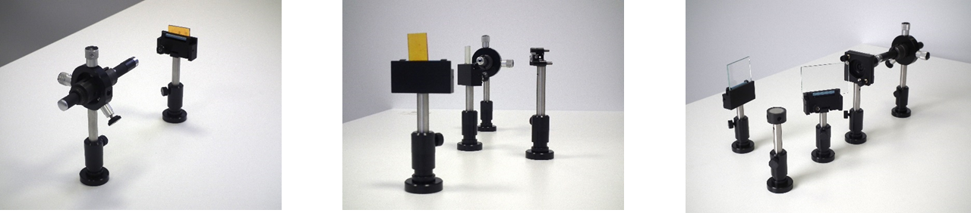

Prototype No. 1 Prototype No. 2 Prototype No. 3

The created learning kits allow the user to get acquainted with the wave-like nature of light, to get acquainted with the light-material interaction, independently obtain diffraction gratings with different periods and record a hologram of an arbitrary object.
Methodical material for teachers and a description of know-how have been prepared. The designs of all three prototypes are registered in the European Community (Application No. 009161318)

